University of Central Punjab
Faculty of Information Technology
Final Term Exam (CSSE3113): Introduction to Software Development (ISD)

Duration | Semester | Percent Weight | Total Marks
2h 30m | Spring 2022 | 40% | 40

Name : _______________________________ Reg #

INSTRUCTIONS
- This is a CLOSED BOOK and CLOSED NOTES exam; Cheat sheet is NOT ALLOWED.
- Attach this question paper with your answer sheet.
- There is a total of 9 questions, and 3 printed pages.
- CALCULATOR SHARING IS NOT ALLOWED
- Providing multiple solutions to a question is not allowed. If multiple answers are found, only the first un-crossed will be checked, and the remaining will be ignored.

Q1. | Draw an Entity-Relationship diagram for the following scenario.  A DVD store wants to keep track of all its musical albums.  - A musical album has a title, price, and a unique identifier as albumId.  - Some artists create albums. We save the artist's name and CNIC for our record.  - One artist can create multiple albums. But one album can only belong to a single artist.  - One album can be of a single genre.  - The genre has genereID, name, and description.  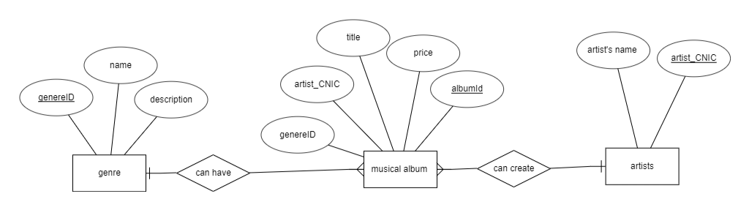  - Multiple albums can have the same genre. | [7]
Q2. | Create a use case diagram of a Restaurant management system. The diagram can have many actors but it must have the Staff, admin, receptionist and customers.  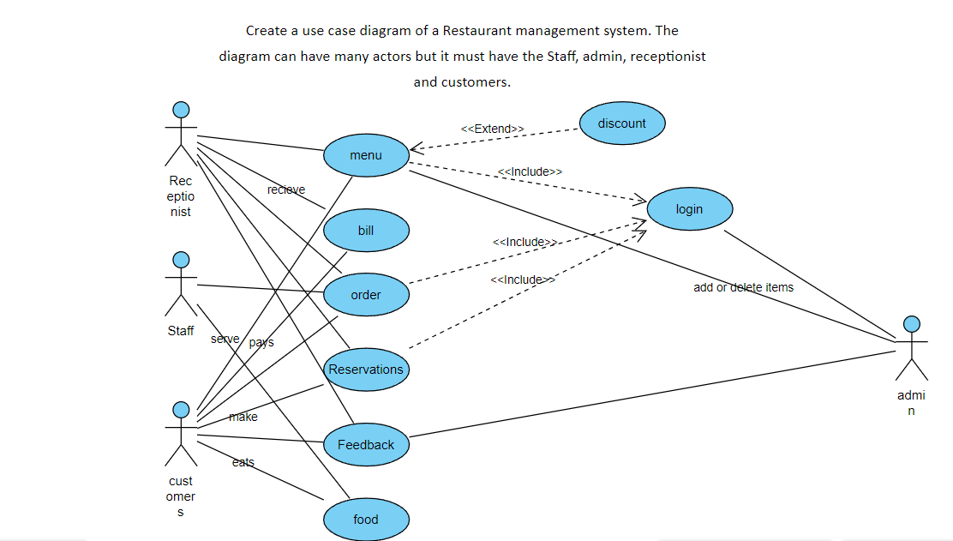 | [6]
Q3. | There are three Designs given for solving a problem of faster execution of customer queries in a banking system. Each has different Benefits and Costs. For the Table given in Figure 3.  - Compute the “Added value” when the company savings are $2500 per year.  - Compute the Return on Investment (for 1 year)  - Compute the Return on Investment (for 5 year)  - Compute the Return on Investment (for 10 year)  - Compute the %gain on ROI (for 1 year)  - Based upon the results of ROI, suggest which design is best choice.  (Note: Added value is computed by calculating the additional requests per second that the system can process in a minute and multiplying that number with savings of company per year.) | [2+2+2+2]
Q4. | Give an example of Include and Extend relationship in use case? | [2]
Q5. | How Aggregation is different from Composition? Briefly explain with example. | [2]
Q6. | Differentiate between validation and verification. | [2]
Q7. | Differentiate between coupling and cohesion with example. | [2]
Q8. | Considering that you would like to buy a new personal car and you have different alternatives as shown in the Table given in Figure 4.  Suppose your priority for defined criteria from top to bottom are 4,1,2,3,4,1,3,1,1.  Perform Trade-off analysis to decide which one is the best one for you. | [3]
Q9. | A software has a 3-point value-based Function Point estimation as shown in Figure 5.  - The adjustment factors of the 14 questions for a software application are: 5,1,0,4,3,5,4,3,4,4,2,3,4,2=44  - The weight factor is simple if EQs < 8. The weight factor is average if EQs >= 8 and EQs <= 12. The weight factor is complex if EQs > 12.  - The average LOC per FP of technology used “C language” is 162.  Calculate effort, development time and average staffing using CoCoMo. Suppose the software is developed within a set of tight constraints.  Use Figure 1 for FP weights and Figure 2 for CoCoMo constants. | [2+2+2+2]
 | Note: Attempt everything on your answer sheet. DO NOT attempt anything in any table/graph given below
Parameters |  | Weight Factor
Parameters |  | Simple | Average | Complex
External Input (EI) | 15 | 3 | 4 | 6 | 60
External Output (EO) | 13 | 4 | 5 | 7 | 65
External Inquiries (EQ) | 9 | 3 | 4 | 6 | 36
Internal Logical File (ILF) | 9 | 7 | 10 | 15 | 90
External Interface File (EIF) | 7 | 5 | 7 | 10 | 49
Total count |  |  |  |  | 300
Figure 1.

∑fi= 5,1,0,4,3,5,4,3,4,4,2,3,4,2=44
FP = Total Count x (0.65+(0.01x∑fi))
FP= 300x(0.65+(0.01x44))
FP=327
The average LOC per FP=162
LOC=(LOC avg x FP)=>(162x327)
LOC= 52974
KLOC= $\frac{52974}{1000}$ =52.974

Effort=ax(KLOC)^{b}
Effort=3.6x52.972^{1.20}
development time=cx(Effort)^{d}
development time=2.5x(Effort)^{0.32}
average staffing=Effort/development time

Figure 2.
Software Projects | a | b | c | d
Organic | 2.4 | 1.05 | 2.5 | 0.38
Semi-detached | 3.0 | 1.12 | 2.5 | 0.35
Embedded | 3.6 | 1.20 | 2.5 | 0.32

Figure 3.
 | Plan A | Plan B | Plan C
Benefits
Search Time | 0.010 sec | 0.012 sec | 0.029 sec
Throughput | 80 requests/sec | 85 requests/sec | 90 requests/sec
Added Value | (80-60)x2500 = 50000 | (85-60)x2500 = 62500 | (90-60)x2500 =75000
Costs
Hardware | $10000 | $15000 | 50000
Software | $50,000 | $200,000 | $100,000
Business Losses | $50,000/yr | $10,000/yr | 50000
Total Cost (1st Year) | $110000 | 225000 | 200000
ROI for 1 year | 50000/110000= 0.45 or 45% | 62500/225000=0.27  Or 27% | 75000/200000=0.375  Or 38%
ROI for 5 year | (50000x5)/ (50000x5)+(60000)= | 62500x5/10000x5)+ (215000) = | 75000x5/200000=
ROI for 10 year | (50000x10)/ (50000x10)+(60000)= | 62500x10/10000x10)+ (215000) = | 75000x10/200000=
%gain on ROI (for 1 year) | (50000)-110000/110000= | ((62500x1)-(10000+215000))/ (10000+215000)x100 | 75000-200000/200000x100
%gain on ROI (for 5 year) | (50000x10) -((50000x5)+(60000)) / ((50000x5)+(60000))= | (((62500x5)-((10000x5)+215000))/ ((10000x5)+215000))x100 | 75000x5-200000/200000x100

 | 4,1,2,3,4,1,3,1,1
Figure 4.

Criteria | Priority | Mercedes | MBW | Audi
Engine | 4 | 16 | 16 | 17
Warranty | 1 | 5 | 4.5 | 5
Interior | 2 | 9 | 8.5 | 9.5
Accessories | 3 | 12 | 12.75 | 11.25
Automatic gears | 4 | 90 | 80 | 100
Shape | 1 | 4.5 | 3.75 | 3.5
Price | 3 | 8.25 | 12 | 8.25
Tank | 1 | 5 | 4.5 | 4.5
Supplier | 1 | 4.5 | 5 | 3.5

Mercedes: (4x16)+(1x5)+(2x9)+(3x12)+(4x90)+(1x4.5)+(3x8.5)+(1x5)+(1x4.5) =521.75

MBW: (4x16)+(1x4.5)+(2x8.5)+(3x12.75)+(4x80)+(1x3.75)+(3x12)+(1x4.5)+(1x5) = 493

Audi: (4x17)+(1x5)+(2x9.5)+(3x11.25)+(4x100)+(1x3.5)+(3x8.25)+(1x4.5)+(1x3.5) = 562

According to calculation the best option is Audi!

Figure 5.

 | Sopt | Slikely | Spess
EIs | 10 | 15 | 20 | (10+(15x4)+20)/6=15
EOs | 10 | 12 | 20 | (10+(12x4)+20)/6=13
EQs | 5 | 9 | 13 | (5+(9x4)+13)/6=9
ILFs | 7 | 9 | 11 | (7+(9x4)+11)/6=9
ELFs | 5 | 7 | 9 | (5+(7x4)+9)/6=7

S=(Sopt+(4xSm)+Spess)/6

